

Power Turf Golf Managers Association of New Zealand
and
New Zealand Golf Course Superintendent’s Association of New Zealand
Summit and Fine Turf Seminar
In association with Golf New Zealand

“Prospering in an unreal world”.

Our timetable
Power Turf GMANZ/NZGCSA Summit and Fine Turf Seminar
Timetable
Day 1 | Power Turf GMANZ/NZGCSA Summit
Sunday 13,June 2021 | Registration desk
Venue | North Plaza Office
5.00pm - 7.30pm | Registration desk open
5.30pm - 7.30pm | Trade exhibition opens
Day 2 | GMANZ/NZGCSA Summit
Venue | SNRC Trade exhibition Hall/Outside display area
7.30am - 5.00pm | Exhibition open
Monday 14,June 2021 | Key note addresses and "Ask the expert" workshops
Venue | BNZ Theatre
8.30am -9.00am | Karakia and Opening addresses
9.00am - 10.15am | "Mental Health Insights"
10.15am - 10.45am | Morning tea
10.45am - 12.00 noon | "Diversity and inclusion"
12 noon - 12.45pm | Suppliers time including mystery challenge
12.45pm - 1.30pm | Lunch
1.30pm - 3.00pm | "Shared value creation to achieve common goals"
3.00pm- 3.30pm | Afternoon tea
3.30pm -4.15pm | "Leadership and team dynamics -Manager/Superintendent relationships"
Monday 14,June 2021 | Power Turf Fine Turf Summit and Fine Turf Seminar
Venue | SNRC Trade Exhibition Hall
7.00pm - 11.00pm | Power Turf dinner
8.30pm | GMANZ and NZGCSA Awards ceremony
Day 3 | GMANZ/NZGCSA Summit
Tuesday 15 June | Key note addresses and Ask the expert workshops
Venue | BNZ Theatre
8.30am - 8.35am | Day 1 review
8.35am - 9.00am | "Biochar - A new way of managing soil and fertility".
9.00am -9:30am | "My Turf Portal"
9.30am -10:00am | "Efficiency through Sustainability"
10.00am - 10.30am | Morning tea
10.30am - 11.15am | "Golf Course Design & Construction"
11.15am - 12 noon | "Course Asset Management & Finance options"
12 noon - 12.45pm | "Tree Management"
12.45pm - 1.30pm | Lunch
1.30pm -2.00pm | "Pest trapping"
2.00pm - 3.00pm | "Growing Degree Days/Soil Moisture Management"
3.00pm -3.30pm | Afternoon tea
3.30pm - 4.15pm | Closing combined workshop
Day 3 | Management Seminar
Tuesday 15 June | Key note addresses and "Ask the expert" workshops
Venue | SNRC Exhibition hall seminar room
8.15am - 9.00am | "Membership retention"
9.00am - 10.00am | "Financial forecasting and planning in an unreal world"
10.00am - 10.30am | Morning tea
10.30am - 11.45am | "Dot Golf/Digital innovation/Data intelligence"
11.45am - 12.45pm | "Maximising other business opportunities - casual golfer/green fee players/driving ranges"
12.45pm - 1.30pm | Lunch
1.30pm - 2.15pm | "How to improve your community engagement"
2.15pm - 3.00pm | "Stressed? How to work smarter not harder"
3.00pm -3.30pm | Afternoon tea
3.30pm - 4.15pm | Closing combined workshop

Master of Ceremonies

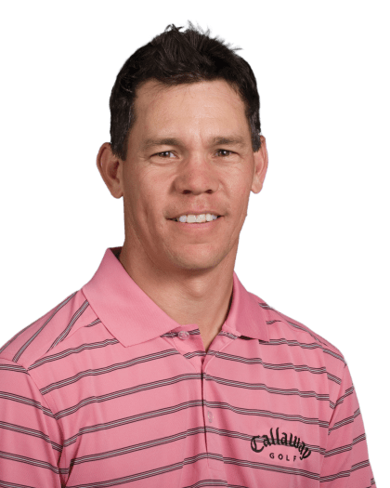
Phil Tataurangi

Welcome – our Presidents.

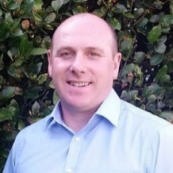
Chris Davies Jason Perkins
President President
Golf Managers Assn of NZ Golf Course Superintendents Assn of NZ

Our opening address speakers

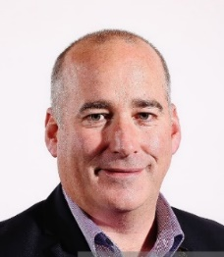
Dean Murphy
CEO
Golf New Zealand


Raelene Castle
CEO Sport New Zealand
Acting CEO High Performance Sport New Zealand

Our Power Turf Summit keynote speakers

'Rewiring for Wellness'


Kristy von Minden
Mind Bright
Auckland

"To inspire individuals to create small but powerful daily habits to take care of their minds so they can discover their mental and emotional strength. Just like we habitually prioritise looking after our physical health by brushing our teeth, eating healthy or exercising.”

Kristy is a certified Mindfulness teacher with a special interest in Neuroscience. An experienced facilitator and keynote speaker, Kristy is regularly invited to speak at events to inspire positive change.
She works regularly with some of New Zealand’s leading businesses, through her company Mind Bright, to reduce employee stress and enhance health, happiness, and performance.

“Ask the Experts” - Health & Wellbeing.
Kristy von Minden
Spencer Cooper
Warren Collett CCM
Peter Boyd

“Diversity and Inclusion in the golf workplace and beyond”

Joint presentation - Sarah Lang and Tupe Solomon-Tanoa’i

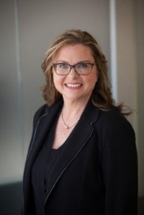
Sarah Lang
Project Director
Infrastructure New Zealand

Sarah Lang is the Project Director at Infrastructure NZ, New Zealand’s peak infrastructure body and think tank. Infrastructure NZ’s purpose is to advance best practice in the development of world class infrastructure through research, advocacy, and public and private sector collaboration.
In 2016 Sarah established the NZ Women’s Infrastructure Network (WIN) and is an advocate for the advancement of women in the infrastructure sector. Sarah was awarded the 2018 NZ Women of Influence Diversity Award, was a nominee for the 2019 New Zealander of the Year Award and received an International Visiting Leadership Programme scholarship from the USA Government in 2019.
Sarah consults to a wide range of public and private sector organisations, through her own business Lang Consulting Ltd. Sarah has developed significant cross-cultural expertise working with iwi groups to enhance economic development opportunities deriving from Treaty settlements.


Tupe Solomon-Tanoa’i
CEO - Michael and Suzanne Borrin Foundation

“I spent years trying to change myself to fit the mould. That was before I realised the power in breaking it.’’
The Kiwi-born, Samoan-Fijian professional has regularly faced what she describes as unconscious bias in the workplace because of her age, gender, and race. Tupe has had to regularly defend her position, even though she has represented New Zealand on the diplomatic stage twice in Taiwan and once in Fiji and held senior positions in the civil service in Wellington. The 40-year-old is currently the chief philanthropy officer for the Michael and Suzanne Borrin Foundation, which supports legal research, education, and scholarships.
Since she graduated with an LLB in 2006, Solomon-Tanoa’i, who won the 2020 NZ Women of Influence Diversity award, has spent her career and personal life pushing for more diversity around board tables, but argues that workplaces need to adapt to be more culturally aware. Last year, she wrote and produced a web series, Misadventures of a Pacific Professional, which follows a young Pasifika woman trying to succeed in a corporate environment.

“Ask the experts” Diversity & Inclusion.
Sara Lang
Tupe Solomon-Tanoa’i
Emily Davidson
Tony Jonas

“Shared value creation – Managers/Course Superintendents collaborating to meet collective goals”.


Kerry Topp
The KDT Collective

Kerry’s an expert facilitator, an inspiring public speaker, and highly respected as a leader who helps mentor and guide those around him. He has 20+ years of experience in operational and strategic leadership and delivery roles in a range of tech businesses including Datacom, Air New Zealand, and Vodafone in New Zealand and internationally.
Kerry is the founder of boutique ecosystem collaboration and innovation specialists, The Kerry Topp Collective. Kerry has significant experience in digital transformation and helps businesses and regions demystify and accelerate ‘Collaborative Leadership and Innovation for Impact’ through a relentless focus on collaboration, innovation, capability growth, and impact.

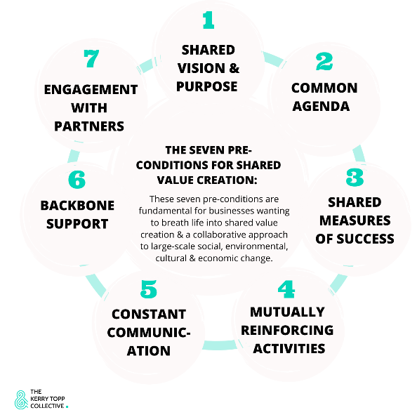
“Ask the experts” Shared value creation Managers/Course Superintendents collaboration
Kerry Topp
Phil Tataurangi
Jason Perkins
Chris Davies

“Leadership and team dynanics”

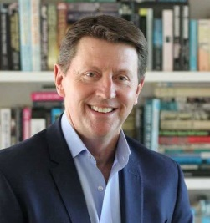

Bruce Cotterill
Business Mentor

“Inspiring leaders and managers to build champion teams and customers for life.”
As a five-time CEO and current Company Chairman and Director, Bruce is a proven transformation leader with extensive experience across a range of industries including real estate, media, financial services, sporting organisations, technology, and retail. He is a passionate leader of change, and he believes that better leadership is critical to improving business performance through people.

Leadership
What are your personal goals? Do you aspire to lead a team? Are you already leading a team but without success or the recognition you crave? Perhaps you aspire to a promotion?

“ Ask the experts” Leadership and Team dynamics
Bruce Cotterill
Ian Litchfield CCM
George Flynn
Leo Barber

Day 2

Fine Turf Seminar

Our facilitators

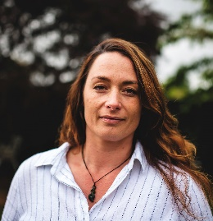
Phil Tataurangi Rebbecca Page
RBT Design Green Start Limited
Principal Taupo
Auckland

Fine Turf Seminar

Our Key Presenters

“Biochar – a new way of managing soil and fertility”

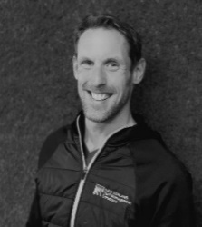
Will Bowden
NZTMS
“The overriding aim of all we do is to broaden the reach and accessability of information available to our industry for the sustainable management of sports surfaces across New Zealand”.

Will Bowden (B.Env.Sc (Hons) has been involved in turfgrass management for over 25 years. He started life in the industry as a greenkeeper in the UK in a career that spanned over a decade, eventually reaching the position of golf course manager/superintendent in the UK as well as one in New Zealand.
Since 2009, Will has been involved in providing education and advice to the turf and recreational sector as an independent turfgrass agronomist and environmental specialist. He spent over 8 years working for SSDM and developing the R&D offerring for the consultancy.
In 2019 Will established New Zealand Turf Management Solutions (NZTMS) and has continued to provide the NZ recreational industry with turfgrass and environmental sustainability advice, with a sharp focus upon R&D and NZ-based research. NZTMS has been working on a number of research projects that aim to enhance the sustainability of sports surface assets. Will and the NZTMS team have developed a niche in the area of turf-related sustainable research and regularly share their findings with the wider industry by way of social media updates and bespoke workshops.

“Ask the experts” - Biochar – a new way of managing soil and fertility.
Will Bowden

“My turf portal”
Joint presentation Alex Glasgow and David Ormsby - NZSTI
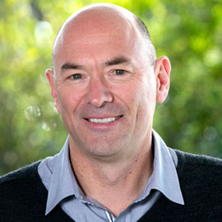
Alex Glasgow
NZSTI
Auckland

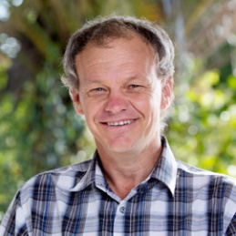
David Ormsby
NZSTI
Waikato

“Ask the experts” My Turf Portal
Alex Glasgow
David Ormsby
Spencer Cooper

“Efficiency through sustainability”
Joint presentation- Rebbecca Page and Will Bowden

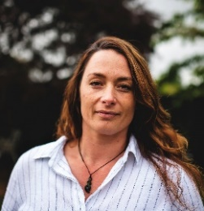
Rebbecca Page
Green Start Limited
Taupo

“Rebbecca is an entrepreneurial leader who inspires and enables through authentic, regenerative, and transformative change. With more than a decade of practical experience delivering multi-faceted specialisations using with sustainability-focused assessments – including GEO verifications, implementation, management, analysis, and communication, Rebbecca doesn't sit on her laurels when it comes to the environment.

As the Founder and Principal Consultant at Green Start, Rebbecca leads a growing team in sustainable development including social good/ impact, assurance and auditing, strategic planning, responsible sourcing, collaborative projects, waste minimisation, resilience and risk management, education, events, and networking. Prior Green Start, Rebbecca held the Sustainability Business Partnership role at Laminex New Zealand, always driving sustainability, with a focus on effective and efficient energy and waste management - award winning in fact,

Rebbecca is currently a candidate for Master of Professional Practice, volunteers as a Mentor with Business Mentors NZ, partners with the University of Waikato Impact Hub to support Interns in practical sustainable projects and is a co-founder and facilitator of Taupō Sustainable Businesses. Outside the office, Rebbecca channels her wilder side by riding a motorcycle and walking her dog in the ngāhere (bush) surrounding Taupō”.

Will Bowden
NZTMS
Auckland

“The overriding aim of all we do is to broaden the reach and accessability of information available to our industry for the sustainable management of sports surfaces across New Zealand”.

Will Bowden (B.Env.Sc (Hons) has been involved in turfgrass management for over 25 years. He started life in the industry as a greenkeeper in the UK in a career that spanned over a decade, eventually reaching the position of golf course manager/superintendent in the UK as well as one in New Zealand.
Since 2009, Will has been involved in providing education and advice to the turf and recreational sector as an independent turfgrass agronomist and environmental specialist. He spent over 8 years working for SSDM and developing the R&D offerring for the consultancy.
In 2019 Will established New Zealand Turf Management Solutions (NZTMS) and has continued to provide the NZ recreational industry with turfgrass and environmental sustainability advice, with a sharp focus upon R&D and NZ-based research. NZTMS has been working on a number of research projects that aim to enhance the sustainability of sports surface assets. Will and the NZTMS team have developed a niche in the area of turf-related sustainable research and regularly share their findings with the wider industry by way of social media updates and bespoke workshops.

“ Ask the experts” Efficiency through sustainability
Rebbecca Page
Will Bowden

Golf course construction and design
Joint Presentation - Phil Tataurangi and Grant Puddicombe

Phil Tataurangi
RBT Design
Principal
Phil Tataurangi was born in Auckland. In 1992 he was a member of the New Zealand's winning Eisenhower Trophy team and was the leading individual player in the tournament. He turned professional in 1993 and played mainly in the United States as a pro. The highlights of his professional career include winning the 1996 Australian PGA Championship and the 2002 Invensys Classic on the PGA Tour.

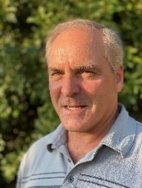
Grant Puddicombe
Puddicombe Golf
Managing Director

Grant got his start in the golf business at an early age working alongside his father and brothers. With a background rooted in golf course maintenance, Grant went on to specialize in the design & construction of golf courses all over Canada, USA, Japan, and New Zealand. The family business was primarily set up as a “design/build”, however they have worked directly with numerous golf course architects over the years which has allowed Grant to learn the pros and cons from other perspectives.
He remains hands-on and is involved in all aspects of design and development through construction to ongoing operations. Grant and his family own and operate golf courses and this diverse experience allows him to understand the golf business from all levels. Grant is the Managing Director of both the Canadian and New Zealand companies operating as Puddicombe Golf and is also the Managing Partner
of the RedTail Landing Golf Club in Canada. Grant, his wife and 2 children live in New Zealand where the company has had a presence since 1989.

“Ask the experts - Golf course design and construction”
Phil Tataurangi
Grant Puddicombe

“Course asset management and finance options”

Ask the experts “Course asset management and finance options”
Peter Boyd
Craig Johnston - Parkland
John Woodham – Power Turf
Leon McPhillips – John Deere

“Tree Management”
Andrew Barrell
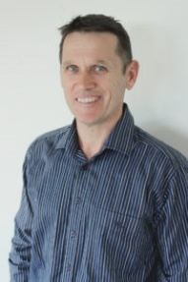
Consultant Arborist
Tree3
Auckland

“Ask the experts – Tree management”.
Andrew Barrell

Pest trapping
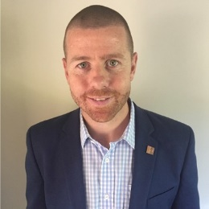
Adam Cording
Goodnature
Wellington
“Ask the experts – Pest trapping”
Adam Cording
Spencer Cooper
DOC

Growing degree days/Soil Moisture Management
PGG Wrightson Turf/Syngenta
Christchurch

“Ask the experts” - Growing degree days/Soil Moisture Management
PGG Wrightson
Alex Glasgow
Will Bowden
David Ormsby

Day 2
Management seminar
Our facilitator

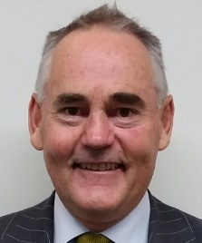
Stephen Gee
Workforce Development Manager
Golf New Zealand

Day 2
Management seminar
Our key presenters

“Membership growth and player retention ”

Dean Murphy
CEO Golf New Zealand
I have been working with Golf New Zealand since 2007, initially spending two years in the role of Commercial Manager. I was appointed as Chief Executive in 2010 after serving as Acting CEO for a year prior to appointment.
Prior to joining Golf New Zealand, I was employed in Sales and Marketing for Lion Nathan as a graduate and spent 10 years in London working in the tourism industry before returning to New Zealand to take up employment with Golf New Zealand.
I am a passionate golfer and am most proud of achieving a hole in one on the Par 4 sixth hole at Paraparaumu Beach Golf Club. In 2018, I was awarded the C.K. Doig Leadership Award at the Sport and Recreation Sector Awards.

“Ask the experts”Membership growth and retention
Dean Murphy
Thiem Nguyen
Chris Davies
Michelle Campbell CCM
“Club Financial Sustainability in an unreal world”
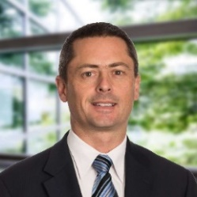
Michael Rondel
Partner – BDO Christchurch
Michael helps lead the audit and assurance advisory division at BDO Christchurch. He has extensive experience both in New Zealand and overseas in providing professional services to medium to large-sized corporate entities and is also involved with a large number of not-for-profit and public sector organisations. Michael is involved at a governance level with a number of not-for-profit organisations. He is a Trustee and Chair of the Risk, Audit and Finance Committee of the Arts Centre Trust Board (a large heritage site in Christchurch), a Trustee and Chair of the International Track & Field Trust (a charitable trust focused on developing pathways for youth into elite athletics) and is currently the Chair and Finance Director at the Canterbury Golf Association and the Harewood Golf Club. He has also undertaken a number of statutory appointment roles at Schools on behalf of the Ministry of Education as well as providing advisory services to a number of Board of Trustees. Michael is also an experienced training facilitator.
Canterbury born and bred; Michael is married with three children. He is a keen sports enthusiast, enjoys watching many sports and is still actively playing football and golf (when time permits) and running for fitness.
“Ask the experts - “Club Financial Sustainability in an unreal world”
Mike Rondel
Warren Collett CCM
Des Topp

“Dot Golf/Digital innovation/Data Intelligence”

Joint Presentation Matt Smith/Chris Davies
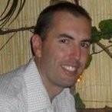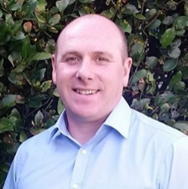
Matt Smith Chris Davies
General Manager General Manager
Dot Golf Ltd Remuera GC
Auckland Auckland

Ask the experts - Dot Golf/Digital innovation/Data Intelligence”.
Matt Smith
Chris Davies
Matt Guzik CCM CCE
Travis Gawler

“More people playing more golf, more often, more of the time – business opportunities - casual golf/green fees/driving ranges”


Chris Davies Thiem Nguyen
General Manager Golf New Zealand
Remuera GC Participation manager
Auckland Auckland

Ask the experts “Business opportunities - casual golf/green fees/driving ranges”
Chris Davies
Thiem Nguyen

Presentation 1: “How to better engage with your local community”.

Presentation 2: “Under post-Covid stress - work smarter not harder”.


Debbie Mayo-Smith
“Debbie Speaks”.
Auckland

Why Debbie?
Your will love Debbie, the most sought-after productivity speaker and trainer in New Zealand and Australia, regularly rated as the top speaker at conferences and companies she works with.
You’ll love Debbie’s warm, relaxed style. In the training environment, Debbie moves individuals from feeling stressed to empowered; overloaded to in-control. Teams find her content entertaining, practical. plain talking; full of how-to’s and tips focusing on helping them with time management; communication and technology. A best-selling author of sixteen books, Debbie was labelled Ms Productivity by the media not just for her work; she is also a mother of six children including twins and triplets!

Ask the experts “How to improve your club’s community engagement”.
Debbie Mayo-Smith
Emily Davidson
“Ask the experts” - Under pressure post Covid? “How to work smarter not harder”.
Debbie Mayo Smith
Mike Hadnett

