
7th ANNUAL REPORT
2022/23
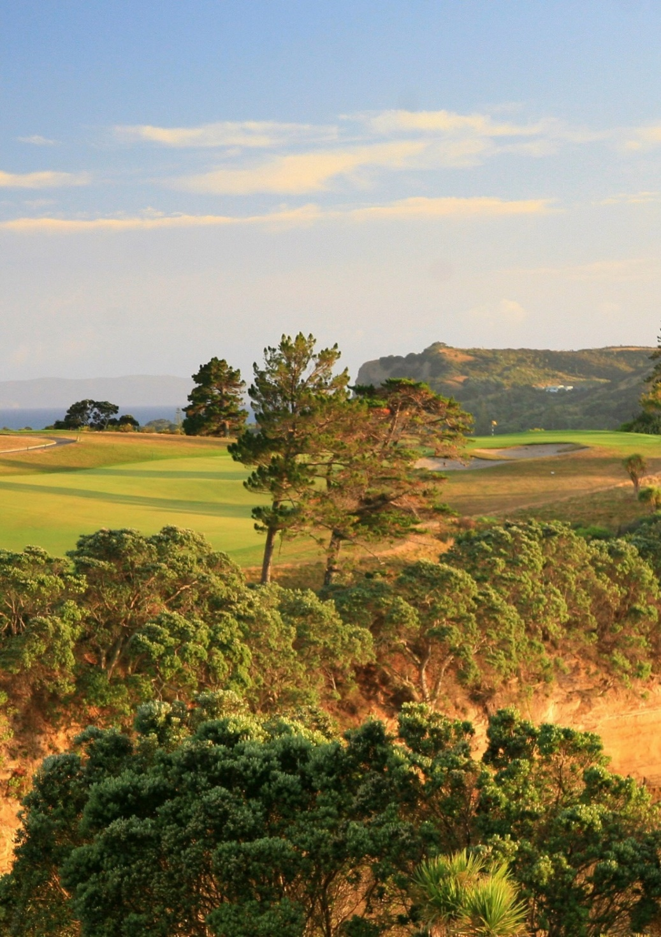



CONTENTS

Notice of 7th Annual General Meeting
Officers of the Council 2022/2023
Minutes of 6th Annual General Meeting
Chair’s Report 2022/2023
Performance Report Contents
NZGIC Entity Information
Statement of Service Performance
Statement of Financial Performance
Statement of Financial Position
Statement of Cash Flows
Statement of Accounting Policies
Notes to the Performance Report
Report Review

NEW ZEALAND GOLF INDUSTRY COUNCIL INC.

NOTICE OF

7th ANNUAL GENERAL MEETING

10.30AM WEDNESDAY

AUGUST 16,2023

JOIN ZOOM MEETING

https://us02web.zoom.us/j/86306838483?pwd=L0I4Z1piTW12ZlNBYWNDb1FVa1NuZz09

Meeting ID: 863 0683 8483
Passcode: 215882
- Welcome,
- Attendance/Apologies
- Confirmation of Minutes of 6th Annual General Meeting -
- Matters Arising Richard Nauck
- Election of Officers
The current directors listed below, appointed by their Associations are elected automatically:
- Andrew Whiley PGA of New Zealand
- Jason Perkins NZ Golf Course Superintendents Association
- Richard Nauck Golf Managers Association of New Zealand
- Thiem Nguyen Golf NZ

The elected directors listed below have completed their three-year term of office and offer themselves for re-election.
- Ryan Brandeburg NZ Golf Tourism
- Denise Langdon ParNZ Golfing Holidays
- John Woodham Power Turf NZ Ltd

- Appointment of Accountant Tim England Chartered Accountant, Howick for annual review purposes
- General Business
- 2024 Golf Matters Conference – Te Pai Convention Centre Christchurch.
Apologies for the Annual General Meeting and Items of General Business must be sent to the Administration Manager at admin@nzgic.co.nz to arrive by 5.00pm Friday 11th August 2023.

Richard Nauck PGA CCM
Chair
July 16, 2023

OFFICERS OF THE COUNCIL 2022/2023
Chair:
Sam Sullivan - Retail NZ Wholesale and Retail Golf Sector - resigned Nov 2022
Richard Nauck PGA CCM – Golf Managers Association of New Zealand - appointed: Nov 2022

Members of the Board representing organisations named in Clause 11.2 of the Constitution:
Andrew Whiley PGA - Professional Golfers Association of New Zealand
Spencer Cooper - New Zealand Course Superintendents Association Resigned Nov 2022
Jason Perkins - New Zealand Course Superintendents Association. Appointed Nov 2022
Dean Murphy - Golf New Zealand - Resigned June 2023
Thiem Nguyen - Golf New Zealand – Appointed June 2023
Retail NZ Wholesale and Retail Golf Sector – Vacant position
Independent Representatives:
Denise Langdon - PaR NZ Golfing Holidays: domestic and outbound golf tourism
John Woodham – Power Turf Ltd: Golf Machinery and Hardware suppliers
Ryan Brandeburg - NZ Golf Tourism: inbound golf tourism



MINUTES OF 6TH ANNUAL GENERAL MEETING
OF NEW ZEALAND GOLF INDUSTRY COUNCIL

Held Online via Zoom

9.00 am Thursday August 25th, 2022.

- Welcome, Present/In Attendance/Apologies
Present:
Sam Sullivan, Des Topp, John Woodham, Matt Smith, Denise Langdon, Ryan Brandeburg, Richard Nauck, Spencer Cooper, Chris Davies, Justin Maunsell, Mike Godinet, Kelly Sauerman

Apologies: Alex Glasgow, Dean Murphy, Nick Sampson, Peter Cox, Alex Glasgow, Terry Yacyshen

Confirmed by the Chairman that the meeting was quorate.
Sam Sullivan/Ryan Brandeburg Carried

- Confirmation of Minutes
Moved that the minutes of the 5th AGM of NZGIC held on 6th Sept 2021 be accepted.
Sam Sullivan/Denise Langdon Carried

- Matters Arising
There were no matters arising.

- Reports
Chairman’s Report - as provided in Annual Report
- Industry’s mix of positive and negative outlooks
- Looking forward to GM 2022
Sam Sullivan/Ryan Brandenberg Carried

Annual Accounts
Moved that the financial report be accepted.
- Noted similar expenditure levels and a slight surplus as the end of year straddled the beginning on Golf Matters income.
Sam Sullivan/Richard Nauck Carried

- Election of Officers 2022/2023
The following were elected unopposed:
Retail/Wholesale Golf - Sam Sullivan
PGA - Andrew Whiley
NZ Golf - Dean Murphy
PaR nz - Denise Langdon
GMA NZ - Richard Nauck
NZ Tourism - Ryan Brandeburg
Power turf - John Woodham
NZGCSA - - Spencer Cooper

- Tim England confirmed as the NZGIC accountant by a show of hands
- SS advised that there was no need to appoint a solicitor for the NZGIC, but the board was able to engage if required in the future.

- General Business
DL talked to the Golf matters conference, noting how close we were to not have one due to Covid restrictions. She noted that we had some great feedback both positive and negative, all of which we could learn from for 2024. She also noted the commitment to return to Te Pae in 2024.
SS thanks DL for the huge effort to get GM2022 off the ground.
MG suggested that a summary of feedback would be a good idea, bullet points for the industry to talk about. MS asked how many respondents there had been, DL indicated around forty or so. CD said he thought it was great to get everybody together post Covid. There were no further questions of comments.

The Chairman thanked members for their attendance and declared the meeting closed.

Meeting closed at 9.20am

Signed as a true and correct record of the meeting.

……………………………………
Chair

…………………………………. Date

CHAIR’S REPORT 2022/2023

On behalf of the Board, it is my pleasure to report on the 2022-2023 activities of the New Zealand Golf Industry Council.
Recovery from COVID is well underway and it is pleasing to note that many clubs and golf businesses continue to flourish in terms of membership and turnover despite all the flags indicating that trading was going to be difficult. Memberships, playing numbers, rounds played, and club bottom line profit are up, courses are in great condition despite excessive rain in some parts of the country, tourists are flocking to NZ for their golfing holidays and demand for course machinery is at an all-time high with long production lead times, all very positive indicators that golf in NZ is in a very good space.
THE WHOLE OF GOLF “GOLF MATTERS” CONFERENCE 2022
The major focus point for the period under review was the 2022 Golf Matters Conference at the spectacular new Te Pae Convention Centre in Christchurch. The Board contracted event management of the Conference to Denise Langdon and Kim Buckley from ParNZ who did a wonderful job in promoting the event, finding suitable speakers, and putting together a very professional event attended by 330 delegates. It is pleasing to report that boosted by tremendous financial support from TourismNZ and ChristchurchNZ the event was able to turn in a healthy profit.
THE WHOLE OF GOLF “GOLF MATTERS” CONFERENCE 2024
NZGIC is contracted to hold a further Golf Matters Conference at Te Pae Convention Centre Christchurch in 2024 and it is pleasing to note that both Tourism NZ and ChristchurchNZ have pledged the same level of financial support ($45K) as for the 2022 event.
We can confirm that August 5-7, 2024, have been penciled in as the provisional dates for the 2024 Golf Matters Conference. We promise that the Conference will be bigger, better, more exciting and with greater attendance numbers than last and strongly suggest that you add those dates to your diary now and include an estimate of expenditure in your 2024 budget.
THE FUTURE - NZGIC FUNDING
In 2017 the Council was setup as a subscription-based model with the idea that any surplus funds generated through membership and events would be invested in an industry focused research project “the economic benefits of the golf industry to the New Zealand economy”. However, COVID put paid to those plans and since then membership of the Council has been subscription free.
The 2022 Conference provided an excellent lift to the Council’s finances and there is hope that a repeat in 2024 would provide the bulk of the funding needed to complete that piece of research.
The Board has discussed in depth the most appropriate membership model going forward and the Chair will update members with further information at the AGM.
BOARD REPRESENTATION
The Board acknowledges the work that its members commit to on a purely voluntary basis with a special thanks going to retiring members Spencer Cooper as the NZ Golf Course Superintendents Association representative, Dean Murphy as the Golf New Zealand representative. They have been replaced by the very capable Jason Perkins and Thiem Nguyen respectively.
Special thanks also to the other members of the team who have given of their time. Their collective input is invaluable.
Andrew Whiley – PGA NZ
Denise Langdon and Ryan Brandenberg – Golf Tourism
John Woodham – Course Machinery and
Des Topp - Administration

Richard Nauck PGA CCM Chair New Zealand Golf Industry Council
NZGIC Database
NZGIC Financial Members
2021-2022 year
Abri Architects Limited |  | John |  | Durkin
Acushnet New Zealand |  | Nick |  | Sampson
Agrowquip Nz Limited |  | Lyndon |  | Baird
Akarana Golf Club |  | Raj |  | Gounden
Apex Insurance |  | Rob |  | Klenner
Asahi Beverages New Zealand |  | Richie |  | Lay
Baber Turf Equipment |  | Robyn |  | Baber
BDO Christchurch |  | Mike |  | Rondel
Canterbury Golf |  | Grant |  | Lewis
Dotgolf |  | Matt |  | Smith
EZGO |  | Peter |  | Talyancich
Golf Encounters |  | Peter |  | Cox
Golf Industry Central |  | Mike |  | Orloff
Golf Management+Marketing |  | Mike |  | Godinet
Golf Managers Association of NZ |  | Des |  | Topp
Golf Media Limited |  | Michael |  | Morris
Golf New Zealand |  | Dean |  | Murphy
Golf Otago |  | Mahal |  | Pearce
Golf Southland Incorporated |  | Linda |  | Suddaby
Golf Technologies |  | Paul |  | Reid
Golf Tourism New Zealand |  | Ryan |  | Brandeburg
Golf Vacations New Zealand Limited |  | Colin |  | Wells
Golf Wellington |  | Steve |  | Weir
Golfer Pacific New Zealand |  | Leigh |  | Smith
Hamilton Golf Club |  | Travis |  | Gawler
Helensville Golf Club |  | Sandy |  | Marsh
Huapai Golf Club |  | Andrew |  | Dewhurst
John Deere Ltd (Australia / New Zealand) |  | Tim |  | Gammage
Kristine Kerr |  | Kristine |  | Kerr
New Zealand Turf Management Solutions |  | Will |  | Bowden
NZ Eagles Society (Judith Capstick) |  | Judith |  | Capstick
NZ Golf Course Superintendents Association |  | Spencer |  | Cooper
NZ Golf Digest |  | Nicholas |  | Cutler
NZ Golf Magazine (Tony) |  | Tony
NZ Maori Golf Association |  | John |  | Cribb
NZ Sports Turf Institute (Alex Glasgow) |  | Alex |  | Glasgow
On Par Advertising |  | Justin |  | Maunsell
PaR nz Golfing Holidays |  | Denise |  | Langdon
Parkland Products Limited |  | Chris |  | Todd
PGA of New Zealand |  | Duncan |  | Simpson
Pin Point Golfing Experiences |  | Mathew |  | Perry
Power Turf |  | John |  | Woodham
Pukekohe Golf Club |  | Jo |  | Beattie
Rain bird Australia (Dave Pearce) |  | Dave |  | Pearce
Remuera Golf Club |  | Spencer |  | Cooper
Sports Surface Design & Management |  | Blair |  | Cornthwaite
The Cut |  | Don |  | Hope
The Golf Warehouse |  | Rhys |  | Bishop
Titirangi Golf Club |  | Richard |  | Nauck
Wairakei Golf + Sanctuary |  | Warren |  | Collett
Waitemata Golf Club |  | David |  | Herbert
Whiley Golf |  | Andrew |  | Whiley

Delegates – NZGIC Golf Matters Conference 2022
Alexandra Golf Club | Dai |  | Johns
Arrowtown Golf Club | Mason |  | Calder
Ashburton Golf Club | Ben |  | Crequer
Avondale Golf Club | Richard |  | Sinclair
Bay of Plenty Golf | Chris |  | McAlpine
Boulcotts Farm Heritage Club | Amy |  | Sidford
Cape Kidnappers Golf | Brad |  | Sim
Carrington Golf Club | William |  | Tan
Carterton Golf Club | Josh |  | Anderson
Chisholm Links Golf Club | Wilson |  | James
Christchurch Golf Club | Mike |  | Hadley
Clearwater Golf | Aiden |  | Berry
Cromwell Golf Club | Jud |  | Rawcliffe
Douglas Links | Sam |  | Keats
Dunstan Golf Club | Mark |  | Hansen
Ellesmere Golf Club | Aaron |  | Chapman
Geraldine District Golf Club | Matthew |  | Rudd
Gulf Harbour Country Club | Peter |  | Speirs
Harewood Golf Club | Richard |  | Attwood
Hastings Golf Club | Michelle |  | Campbell
Jacks Point Golf | John |  | Griffin
Judgeford Golf Club | Lyn |  | Farnsworth
Kauri Cliffs | Andy |  | Wood
Manawatu Golf Club | Kiel |  | Stechman
Manawatu Wanganui Golf | Geoff |  | Ross
Mangawhai Golf Club | Jamie |  | Thomas
Maraenui Golf Club | Phil |  | Carew
Maungakiekie Golf Club | Hugo |  | Littlejohn
Millbrook Resort | James |  | O'Malley
Mount Maunganui Golf Club | Michael |  | Williams
Muriwai Golf Links Club | Andrew |  | Jackson
New Plymouth Golf Club | Neville |  | Maindonald
North Golf | Cory |  | Hitchen
North Shore Golf Club | Rowland |  | Griffiths
Ohope Beach Golf Links | Tony |  | Pothan
Omanu Golf Club | Jason |  | Perkins
Onewhero Golf Club | Adam |  | Muir
Otago Golf Club | Shelley |  | Duncan
Otaki Golf Club | Jamie |  | Lamplough
Pakuranga Golf Club | Peter |  | Boyd
Paraparaumu Beach Golf Club | Leo |  | Barber
Pegasus Golf & Sports Club | James |  | Devlin
Poverty Bay Golf Club Inc. | William |  | Brown
Pupuke Golf Club | Matthew |  | Owen
Queenstown Golf Club | Andrew |  | Bell
Redwood Park Golf Club | Dan |  | Godek
Royal Auckland & Grange Golf Club | Mark |  | Hooker
Royal Wellington Golf Club | Dylan |  | Lindstrom
Russley Golf Club | Giles |  | Beal
St Clair Golf Club | Annette |  | Godman
Tara Iti Golf Club | Matt |  | Guzik
Tauranga Golf Club | Michelle |  | Towersey
The Hills Golf Club | Ben |  | Taylor
The Morgans Golf Course | Dane |  | Crawford
Timaru Golf Club | Graeme |  | Brown
Waikanae Golf Club | Andy |  | Rutter
Waikato Golf | Terry |  | Booth
Waimairi Beach Golf Club | Wayne |  | Turner
Wainui Golf Club | Terry |  | Yasychen
Waipu Golf Club | Duncan |  | Rhind
Wairekei Golf + Sanctuary | Steven |  | Jessup
Weedons Golf Club | Clarke |  | Vincent
Whakatane Golf Club | Richard |  | Winslade
Whangamata Golf Club | Richard |  | White
Whangaparoa Golf Club | Carly |  | Webster
Whitford Park Golf Club | Ricky |  | Scammell
Windross Farm Golf Club | Andre |  | Arthur

Partners and Trade Exhibitors – NZGIC Golf Matters Conference 2022
Barley Station | Kit |  | Gordon
Biom NZ (Rui Jiang) | Rui |  | Jiang
Brittain Wynyard & Co | Sam |  | Sullivan
Callaway Golf South Pacific | Matt |  | Meredith
ChristchurchNZ | Megan |  | Crum
Commercial Outdoor Machinery | Jo-Anne |  | de Villiers
Country Club International Pty Ltd | Brock |  | Agnew
Dancing on Moonlight | Sam |  | Langrope
Elevate Sports Company Ltd (Shane Coles) | Shane |  | Coles
Fieldquip Pty Ltd | Terry |  | Griffiths
FlingGolf New Zealand | David |  | Blake
Goalpost Projects Ltd | Geoff |  | Andrew
Golf & Irrigation Limited | Hamish |  | Parker
Golf Distributors | Sheridan |  | Vining
Henrich NZ Ltd (Katherine Tian) | Katherine |  | Tian
Hunter Industries | Tim |  | Curnow
Ingram Micro NZ | Roneel |  | Prasad
James Whelan | James |  | Whelan
Kiss My Putt | Janie |  | Reese
Lawn & Turf | Mike |  | Glasson
Living Turf NZ | Hollie |  | Wright
Millbrook Tournaments | Michael |  | Glading
My Fleet - Tuatara | Angela |  | Ransley
New Zealand Sports Turf Institute | Kelly |  | Sauerman
NZ BioGro Certified | Rui |  | Jiang
OMC Power Equipment | Manfred |  | Watt
One Stop Golf Shop | David |  | Keown
Palmerston North City Council | Kim |  | Linton
PGG Wrightson Seeds Limited | Sean |  | Zumbraegel
Pip Idour | Pip |  | Idour
Prebble Seeds Limited | Bruce |  | Lowe
Raintech Limited | Steve |  | Martin
Ransomes Jacobsen Ltd | Peter |  | Schumacher
Ready Lawn | Roger |  | Morgan
Reel Doctor Christchurch | Iain |  | Findlater
Safety Online 2014 Ltd | Bob |  | Parsons
SHANX Mini Golf | Peter |  | Vlahandreas
Shaping Dirt Limited | Blake |  | Lindsay
SNAG Golf | David |  | Thompson
Southern Turf Managers Association | Craig |  | Parata
Sport New Zealand | Casey |  | Henwood
Sustainable Machinery Pty Ltd | Jason |  | Hatton
Syngenta Professional Solutions | Bevan |  | Houghton
T.I.C Projects | Wayne |  | Holmes
Taranaki Golf Association | Nick |  | Northam
Teed Up Golf Tours | Bede |  | Hendren
That Lawn Company | Cambell |  | Devany
TIC Projects | Wayne |  | Holmes
Tourism New Zealand | Sherylee |  | Eyles
Trenchit - Terraway Attachments Ltd | Janine |  | Cooney
Water Supply Products | Tim |  | Curnow
Wellington Regional Stadium Trust | Hayden |  | Faith
Womens Golf Magazine (Paridigm Collective) | Nicci |  | Herrera

