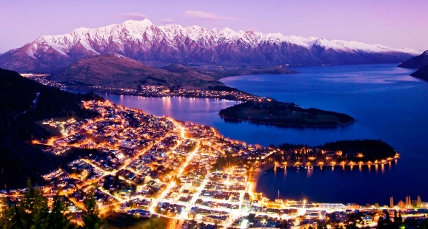

“INNOVATE CHANGE SUCCESS”

8th Biennial Golf Managers Association
of
New Zealand Conference
Queenstown – New Zealand
9-11 October 2018

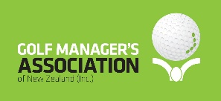

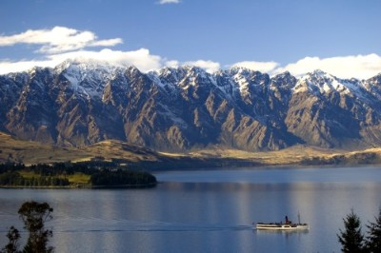

“INNOVATE CHANGE SUCCESS”

The 8th Biennial GMANZ Conference Programme
The three-day programme will be a combination of keynote presentations, classroom style interactive sessions, round table debates and social networking

Tuesday 9th October Day Host TBC

Time | Details / Session Venue | Speaker(s) | Dress Code

GMANZ GOLF
TOURNAMENT

10.30am Coach departs Queenstown Golf club Golf attire

11.30am Lunch served

12.30pm Golf shotgun start

5.00pm Prize giving

5.30pm Coach departs Hotel

6.45pm | Conjoint CMAA Closing  GMANZ Opening  Dinner  Coach departs  For Gondola and Skyline  Restaurant | Skyline Restaurant |  | Smart Casual
7.00pm | CMAA/GMANZ  Conjoint Dinner
7.15pm  7.25pm  8.30pm  9.00pm  10.30pm | BMI International Conference  Closing Remarks  GMANZ Conference  Opening remarks  Keynote Speaker  Entertainment  Coach departs for Hotel | CEO CMAA  President  GMANZ

 |  |  | Queenstown  Golf Club | Golf attire
  Wednesday 10th October Day Host
  Time |  | Details / Session | Speaker(s) Venue |  |  |  |  |  |  |  |  |  |  |  |  | Dress Code
  8.00am – 9.00am Registration
  9.10am – 9.15am  9.15am – 9.45am | Opening address  Welcome |  |  |  | GMANZ President  Jim Boult  Mayor of Queenstown |  |  |  | Millennium Hotel |  |  |  |  |  |  |  | Smart Casual
  9.15am – 10.00am  10.00am – 11.00am | Business Session 1 Dean Murphy NZ Golf  Business Session 2 TBC
  11.00am – 11.20am | Tea / Coffee Break
  11.20am – 12.00pm | Business Session 3 TBC
  12.00pm – 1.00pm  12.00pm – 1.15pm | Lunch  Trade Show
  1.15pm – 1.55pm | Trade Show Exhibitors  Presentations
  1.55pm - 3.00pm | Business Session 4
  3.00pm – 3.20pm | Tea / Coffee Break
  3.20pm – 4.00pm  4.00pm – 4.45pm | Business Session 5  Business Session 5  Trade show Exhibitors  Presentations  Evening free
  Thursday 11 October Day Host TBC
  Time |  |  |  | Details/ Session |  |  |  |  |  |  |  |  |  | Speaker(s) |  |  |  | Venue |  | Dress Code
  8.00am – 9.15am |  |  |  |  |  | Trade Show |  |  |  |  |  |  |  |  |  | Millennium Hotel |  |  |  |  | Smart casual
  9.00am – 10.0am |  |  |  |  |  | Business Session 1 |  |  |  |  |  |  |  |  | TBC
  10.30am – 11.00am |  |  |  |  |  | Tea / Coffee Break
  11.00am – 12.00pm |  |  |  |  |  | Business Session 2 |  |  |  |  |  |  |  |  | TBC
  12.00pm – 1.00pm |  |  |  |  | Lunch
  1.00pm-1.30pm  1.30pm – 3.00pm |  |  |  |  | Annual General Meeting  GMANZ  Business Session 3  Panel Discussion |  |  |  |  |  |  | Facilitator 1  Facilitator 2  Facilitator 3
  3.00pm – 3.15pm |  |  |  |  |  | Tea / Coffee Break
  3.15pm – 4.30pm |  |  |  |  |  | Keynote speaker |  |  |  |  |  |  |  |  | TBC
  4.30pm – 4.45pm |  |  |  |  |  | Closing Speech |  |  |  |  |  |  |  |  | GMANZ President
Note:
Afternoon programme time table to be confirmed – will be subject to airline departure times.

“INNOVATE CHANGE SUCCESS”
Accommodation
Millennium Hotel Queenstown
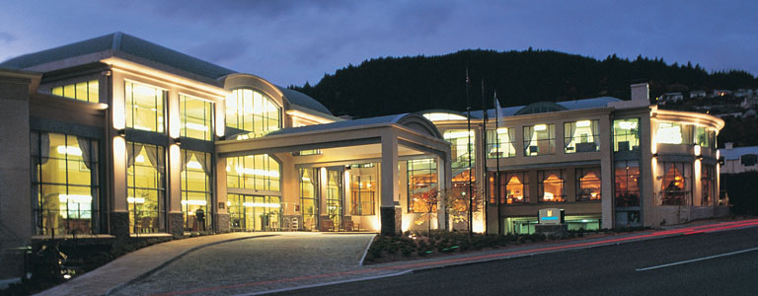
Be at the heart of Queenstown action
Right in the heart of the action, Millennium Hotel Queenstown is just minutes from Queenstown central shopping, entertainment and outdoor activities such as bungy jumping, white water rafting, and jet boating. The popular ski destinations of Coronet Peak, Remarkables, and Cardrona are also close by.
Our 220 guest rooms and suites, meetings facilities, business centre, gym, sauna, spa, bar and restaurant, feature contemporary city-inspired designed. Our luxury hotel also offers accessible rooms for our special needs guests with our friendly staff on hand to assist you anytime. Most of our accommodation also offers scenic views of Queenstown city and mountains, providing the perfect backdrop to your trip.
The Millennium Hotel offers GMANZ delegates a very competitive rate per night (single or double occupancy or twin share. The rates include a full breakfast buffet and relevant taxes)
While there are many hotels In Queenstown, we sincerely recommend staying at the Millennium Hotel to avoid delegates spending time travelling to and from venues being used throughout the GMANZ Conference. Other hotels in the same district are charging considerably more than this special rate negotiated specially for delegates.
For further details on the hotel please use the contact details below or visit their website:
Millennium Hotel
32 Frankton Road Queenstown New Zealand 9300

+64 3 450 0150
www.millenniumhotels.com/en/queenstown/millennium-hotel-queenstown/

Travel Information
Queenstown is served extremely well, giving a variety of airline service options to delegates to the GMANZ conference from anywhere in the New Zealand through our sponsors.

Queenstown Airport is located 12 kilometres from downtown Queenstown. The Millennium Hotel provides free of charge transport for its guests to and from the airport.,
The Concierge at The Millennium Hotel will be happy to pre-book any taxi requirements during your stay.
………………………………………………………
Dress Code

The dress code for the conference is smart casual.
The dress code for the golf day is golf casual. Note the Queenstown Golf Club does not allow denim clothing, training shoes and collarless shirts.

…………………………………………………………………………………………

