


BMI International – Queenstown New Zealand – 2018

Partners Programme

Milford Sound Fly/cruise/fly tour
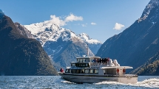
Join us for the ultimate day-trip to New Zealand's unforgettable Milford Sound. Experience for yourself the
grandeur and stunning beauty of a place where mountains plunge steeply into a deep fiord teeming with rare
wildlife. You'll soon see why Milford Sound is one of the world's greatest destinations as you take in the scale of
this natural wonder from both the air and sea.

-------------------------------------------------------

Kawarau Bridge Bungy
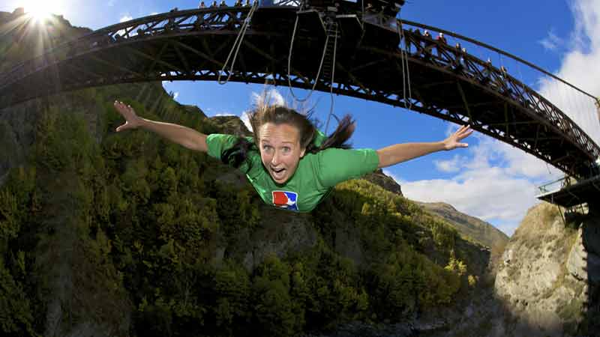
A piece of living adventure history the Kawarau Bridge was the site Bungy Pioneers AJ Hackett and Henry Van Asch
first leapt into the global spotlight when they launched the world’s 1st commercial bungy jumping operation back
in 1988.
Now with over 27 years’ experience thrilling visitors, and helping to secure Queenstown’s reputation as the
Adventure capital of the World, The Kawarau Bridge Bungy is still seen as a right of passage for those looking to
complete an authentic Queenstown adventure.

Face the fear and feel the adrenaline as you step up to the edge and secure your place as a conqueror of the
legendary Kawarau Bridge Bungy .

----------------------------------------------------

Shotover jet boat
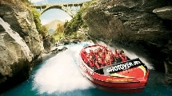
Get ready for the thrill of a lifetime with New Zealand's world famous Shotover Jet - the ultimate jet boat
experience!
Feel your adrenalin surge as you accelerate into the towering Shotover River Canyons. Your expert driver takes
you skimming through the shallows in mere centimeters of water, blasting past the canyon walls, rocky outcrops
and boulders. Everything blurs into your periphery as the specially designed 'Big Red' Jet Boat reaches speeds of
up to 85kmph.

-----------------------------------------------------

Nomad Safaris - Safari of the Scenes - Glenorchy
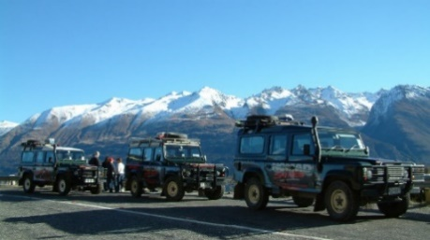
For Lord of the Rings fans, this is the trip where Nomad Safaris really does take you There and Back again! Bring the films to life with our authentic replica props, dress up and take photos, or simply soak up the scenery!
Visit the filming locations for Isengard, the Ithilien Camp, Lothlorien forest and the Seat of Seeing/Battle of Amon Hen, plus filming locations from the Hobbit trilogy! This scenic safari offers breathtaking mountain and forest views along the shore of Lake Wakatipu towards Glenorchy and the Paradise Valley.
------------------------------------------------------

Half Day Remarkables Range Guided Short Walks - Climbing Queenstown
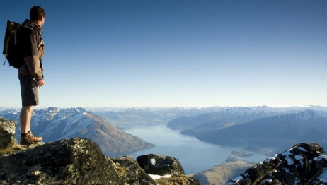
The Remarkable Alpine range is undoubtedly the finest in the country, renowned for its spectacular hiking/trekking terrain and awe-inspiring views.
Your guide will take you on a hike tailored to your fitness and experience level, exposing you to the most breathtaking sights of this alpine wonderland.
Escape the crowds and discover this renowned beauty at your own pace. Our highly skilled and qualified guides uncover dramatic scenic vistas and unforgettable views over Queenstown (some 2000 meters below) and the Southern Lakes area.
A truly exhilarating and authentic way to experience the remote treasures of this alpine paradise.
-------------------------------------------------------
Bike The Wineries Tour
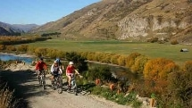
Take a break from the slopes and enjoy Queenstown crisp, clear winter days with a full day self-guided Bike The Wineries Tour over some of New Zealand’s best loved trails exploring wineries at your leisure. Your journey will begin with a scenic and informative transfer to the quaint village of Arrowtown which is steeped in rich gold-mining history. Here you can enjoy one of the many cafes or get straight on your bike and take to the picturesque Arrow River Trail.
---------------------------------------------------------
Half Day Electric Bike Hire
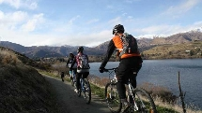
Hire an electric bike and explore the scenic delights of Arrowtown!
Fast becoming a very popular choice for all levels of fitness and ability, electric bikes are a fun and exciting way to discover the region. Let the electrics assist you up hills, help you to go further or just for the pleasure of riding an electric bike. You choose how much assistance you want, maybe less on the flat and more on the hills.
---------------------------------------------------------

The Queenstown Wine Tour Company
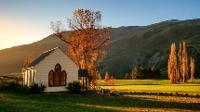
Soak up the magic Central Otago vistas as you sample a little Queenstown magic in your glass.
Spend a day with The Queenstown Wine Tour Company, visiting 4 award-winning vineyards and enjoying 4-8 varieties at each. You’ll be taken on a subterranean adventure through New Zealand’s largest underground wine cave and taste local culinary delights over a leisurely lunch.
-----------------------------------------------------
Kiwi Birdlife Park
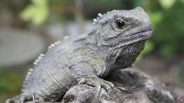
Come enjoy the sights, sounds and textures of the New Zealand bush and wildlife in our 5-acre sanctuary. New Zealand is home to an amazing array of unique wildlife, the Park allows you to see these animals and learn all about them right in the heart of Queenstown. We have over 20 species of native wildlife on display, including New Zealand's national icon, the kiwi and our living fossil, the tuatara. Most of the animals held at the park are part of nationally managed breeding programmes for conservation.
----------------------------------------------------
Onsen Hot Spa pamper package
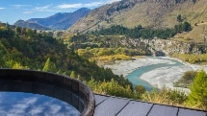
While Queenstown is generally done at full pace, Onsen Hot pools takes a step back to let you take in the beauty of the surroundings and simply relax. With uninterrupted views across the Shotover Canyon, our Cedar Hot Tubs are heated to 37.8C on warmer days and up to 39.8C during the winter and can accommodate up to four adults.
-----------------------------------------------------------
Body Sanctum's 1hr Tranquility Massage
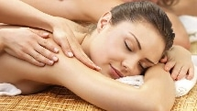
The perfect way to relax, unwind and get in the holiday spirit. Body Sanctum provides the ultimate in massage experiences combining the skills of expert therapists with a luxurious setting to ensure you are transported far away from life's stresses.
Body Sanctum's 1hr Tranquility Massage is a traditional relaxation style massage using long flowing, kneading strokes.
-----------------------------------------------------------

